LIZENZTEXT für den Song

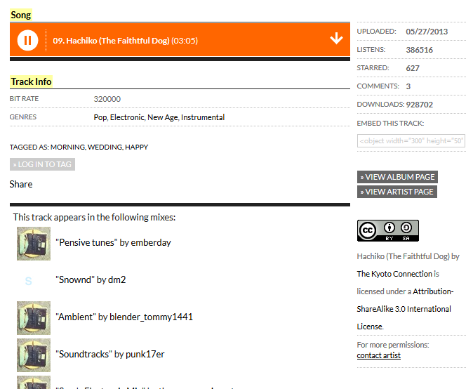
Hachiko (The Faithtful Dog) by The Kyoto Connection is licensed under a Attribution-ShareAlike 3.0 International License.

CC BY-SA: Attribution-ShareAlike. This license lets others remix, tweak, and build upon your work even for commercial purposes, as long as they credit you and license their new creations under the identical terms. All new works based on yours will carry the same license, so any derivatives will also allow commercial use. This is the license used by Wikipedia, and is recommended for materials that would benefit from incorporating content from Wikipedia and similarly licensed projects.
How to use it: You must credit the artist. You can put this song in a video or other derivative work. You can use it for commercial purposes. You must add the same license (CC BY-SA) to your video, remix or derivative work. More permissions must be obtained directly from the artist.

